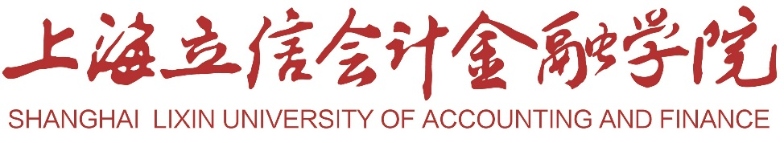

RANKING CERTIFICATE

This to certify that ******,female,Student ID:*********,was admitted to class No.* in ** Major of the School of *** of Shanghai Lixin University of Accounting and Finance,in Sep.2018,ranking 6th among a total of *** students in the major.

Shanghai Lixin University of Accounting and Finance
June 27h,2022

